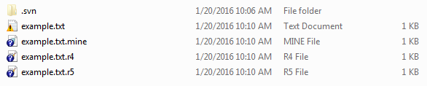
In above screenshot:
example.txt.mine là file mình đã chỉnh sửa rồi
example.txt.r4 là file trước khi chỉnh sửa
example.txt.r5 là file đang nằm ở trên VisualSVN Server

Workflow:
User A checks out a folder which contains file.txt (File.txt on Visual SVN server is revision 1)
User B checks out a folder which contains file.txt (File.txt on Visual SVN server is revision 1)
User A edits file.txt then commits (After commiting, File.txt on Visual SVN server is revision 2)
User B edits file.txt then commits => Commit failed popup is displayed ( File.txt on Visual SVN server is revision 2 but File.txt on User B's pc is revision 1 which is older than revision 2. That's why conflict happens)

